**C. Report No. 3 Software Requirement Specification**  
**1. User Requirement Specification**

***1.1 Admin Requirement:***

Admin is a person who has permission to manage some action of the project. To use all functions, user must login. There are some functions admin can use:

* Login
* Manage user:
  + Create, update, Activate /deactivate user
* Manage department:
  + Create, update, Activate /deactivate department
* Manage room:
  + Create, update, Activate /deactivate room
* View schedule
  + View mission schedule
  + View meeting schedule
  + View shift schedule

***1.2 Manager Requirement:***

Manager who has higher privileges than the scheduler. They have permission to approve and change status of one mission. The manager can use some following functions:

* Login
* Manage schedule:
  + Create, update, Activate /deactivate, approve mission schedule
  + Create, update, Activate /deactivate, approve meeting schedule
  + Create, update, Activate /deactivate, approve shift schedule
* Manage notification:
  + Create, update, Activate /deactivate, approve notification
* View schedule
  + View mission schedule
  + View meeting schedule
  + View shift schedule

***1.3 Scheduler Requirement:***

Scheduler guest who already login to the system by his/her account and uses service of system. The scheduler can use some following functions:

* Login
* Manage schedule:
  + Create, update mission schedule
  + Create, update meeting schedule
  + Create, update shift schedule
* View schedule
  + View mission schedule
  + View meeting schedule
  + View shift schedule

***1.4 User Requirement:***

User is normal staff of hospital they are only able to view the calendar. The user can use some following functions:

* Login
* View schedule
  + View mission schedule
  + View meeting schedule
  + View shift schedule

**2. System Requirement Specification**  
**2.1 External Interface Requirement**  
**2.1.1 User Interface**

* General requirement for graphics user interface is the GUI should be simple, clear, intuitive, and reminiscent.
* User interface is display all by English.
* The user interface uses consistent palette of colors between the text and the background.
* The user interface displays best on 1600x900-screen size.

**2.1.2 Hardware Interface**

* RAM: 2GB
* CPU: 1.2GHz
  + 1. **Software Interface**
* Web application: work with Firefox (v30 or above), Chromes (v14 or above), Internet Explorer (v10 or above) browse

**2.1.4 Communication Protocol**

* Use HTTP protocol 1.1 for communication between the web browser and the web server.

**2.2 System Overview Use Case**

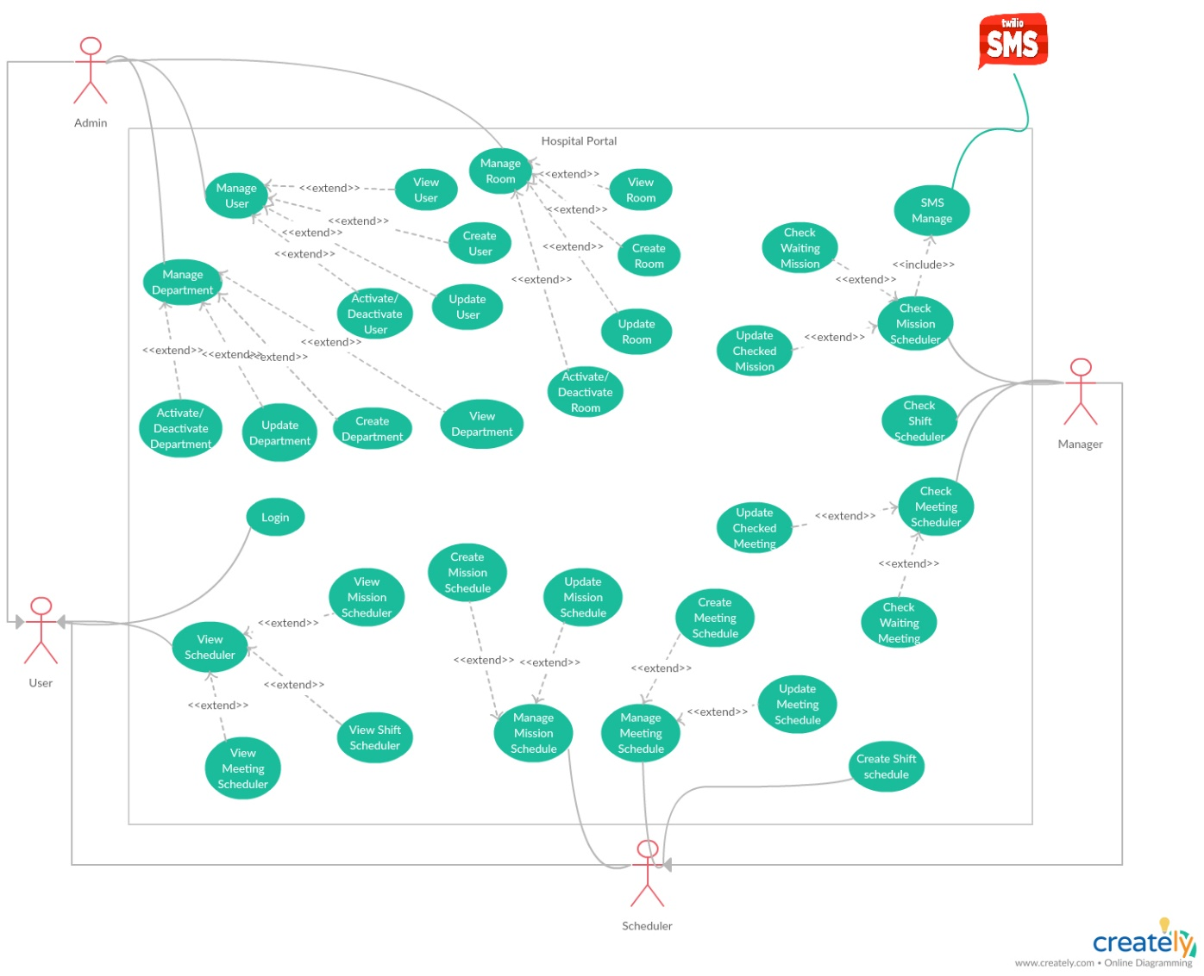

* 1. **List of Use Case**

***2.3.1 <Admin>Overview Use Case***

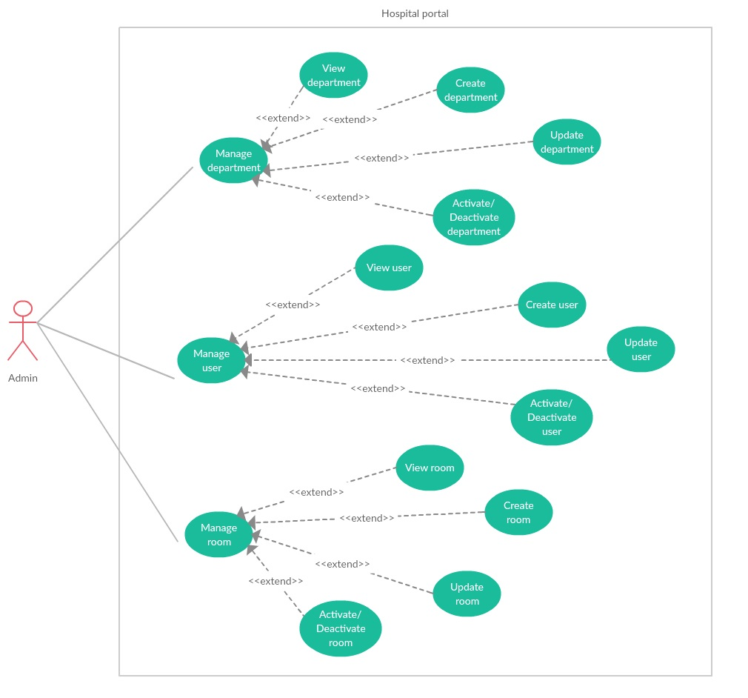

***2.3.1.1 <Admin> Manage user***

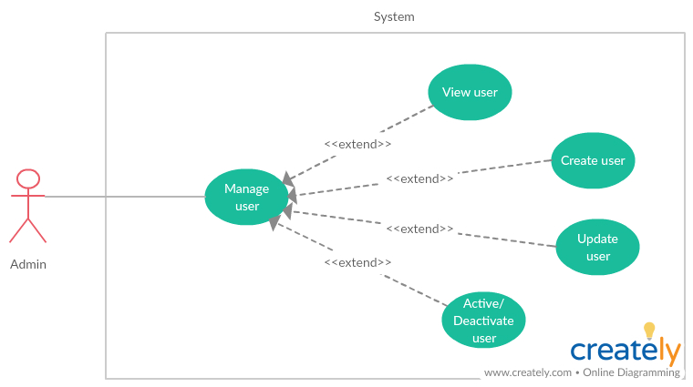

***2.3.1.1.1 <Admin> View user***

|  |  |  |  |
| --- | --- | --- | --- |
| **USE CASE -** UC_HP01 | | | |
| **Use Case No.** | UC_HP01 | **Use Case Version** | 2.0 |
| **Use Case Name** | View user by Admin | | |
| **Author** | LinhTP | | |
| **Date** | 17/1/2018 | **Priority** | Normal |
| **Actor:**   * Admin.   **Summary:**   * This use case allows Admin to view list user and detail.   **Goal:**   * Admin can view all user and user information.   **Triggers:**   * Admin click tag [Manage User] on menu bar.   **Preconditions:**   * System had connected to database. * User login with role Admin.   **Post Conditions:**   * **Success:** System show all user and detail. * **Fail:** System display “Error” message.   **Main Success Scenario:**   |  |  |  | | --- | --- | --- | | Step | Actor Action | System Response | | 1 | Admin click tag [Manage User] on menu bar. | System move to interface, where show all users in list.  On each row there are:  -Username  -Full name  -Department  -Position  -Role  -Phone  -Status  -View icon.  [**Alternative 1]** | | 2 | Admin click [View] icon on selected user row | System show user detail page.  On page is all user info load from database:  -Username  -Email  -Full name  -Sex  -Day of birth  -Department  -Phone  -Position  -Address  -Certificate  -Role |   **Alternative Scenario:**   |  |  |  | | --- | --- | --- | | No | Actor Action | System Response | | 1 | There is no user in the data | Show label massager “There is no user in the data”. |   **Exceptions:**   |  |  |  | | --- | --- | --- | | No | Actor Action | System Response | | 1 | Disconnect to server | System show message the “Connection to the server has been lost. Please check your internet connection or try again later. ” when the internet is lost |   **Relationships:** N/A  **Business Rules:**   * Paging list user. * Have search box, and filter by department. * The displayed information must be match the employee information. | | | |

***2.3.1.1.2 <Admin> Update user***

|  |  |  |  |
| --- | --- | --- | --- |
| **USE CASE -** UC_HP02 | | | |
| **Use Case No.** | UC_HP02 | **Use Case Version** | 2.0 |
| **Use Case Name** | Update user | | |
| **Author** | LinhTP | | |
| **Date** | 17/1/2018 | **Priority** | Normal |
| **Actor:**   * Admin.   **Summary:**   * This use case allows Admin to update user detail.   **Goal:**   * Admin can update user information.   **Triggers:**   * Admin click [Update] icon.   **Preconditions:**   * User login with role Admin. * System had connected to database. * Selected User exited in database.   **Post Conditions:**   * **Success:** User information updated in data. * **Fail:** System display “Error” message.   **Main Success Scenario:**   |  |  |  | | --- | --- | --- | | Step | Actor Action | System Response | | 1 | Admin click tag [Manage User] on menu bar. | System move to interface, where show all users in list.  On each row there are:  -Username  -Full name  -Department  -Position  -Role  -Phone  -Status  -View icon.  [**Alternative 1]** | | 2 | Admin click [Update] icon on selected user row | System show update user page.  [**Alternative 2]**  On popup is all user info load from database.  -Username (cannot change): textbox up to 50 characters long.  -Email (require): Text box with email validation.  -Full name (require): textbox, Does not contain numbers or special characters, up to 128 characters long.  -Sex (require): Combo box.  -Day of birth (require): date picker.  -Department (require): Select from Department dropdown list.  -Phone (require): Text box, only up to 20 numbers.  -Position (require): multiple choice list.  -Address (require): Text area.  -Certificate: Text area.  -Role (required): Select from role dropdown list. | | 3 | Admin input new information in update form. | System validation after information inputted. | | 4 | Admin click [save] button | Appears notification dialog  “Success” |   **Alternative Scenario:**   |  |  |  | | --- | --- | --- | | No | Actor Action | System Response | | 1 | There is no user in the data | Show label massager “There is no user in the data”. | | 2 | Admin click “Back” button | Back to user list page. |   **Exceptions:**   |  |  |  | | --- | --- | --- | | No | Actor Action | System Response | | 1 | Disconnect to server | System show message the “Connection to the server has been lost. Please check your internet connection or try again later. ” when the internet is lost |   **Relationships:** Activity history  **Business Rules:**   * Information validation by hospital requirement template. | | | |

***2.3.1.1.3 <Admin> Create user***

|  |  |  |  |
| --- | --- | --- | --- |
| **USE CASE -** UC_HP03 | | | |
| **Use Case No.** | UC_HP03 | **Use Case Version** | 2.0 |
| **Use Case Name** | Create user | | |
| **Author** | LinhTP | | |
| **Date** | 17/1/2018 | **Priority** | Normal |
| **Actor:**   * Admin.   **Summary:**   * This use case allows Admin to create new user.   **Goal:**   * Admin can create new user.   **Triggers:**   * Admin click [Create new user] button.   **Preconditions:**   * System had connected to database. * User login with role Admin.   **Post Conditions:**   * **Success:** New user create in data. * **Fail:** System display “Error” message.   **Main Success Scenario:**   |  |  |  | | --- | --- | --- | | Step | Actor Action | System Response | | 1 | Admin click tag [Manage User] on menu bar. | System move to interface, where show all users in list.  On each row there are:  -Username  -Full name  -Department  -Position  -Role  -Phone  -Status  -View icon.  [**Alternative 1]** | | 2 | Admin click [Add] button. | System show Create user page.  [**Alternative 2]**  On popup is user info input form:  -Username (cannot change): textbox.  -Email (require): Text box with email validation.  -Full name (require): textbox, Does not contain numbers or special characters, up to 128 characters long.  -Sex (require): Combo box.  -Day of birth (require): date picker.  -Department (require): Select from Department dropdown list.  -Phone (require): Text box, only up to 20 numbers.  -Position (require): multiple choice list.  -Address (require): Text area.  -Certificate: Text area.  -Role (required): Select from role dropdown list. | | 3 | Admin input user information in create form. | System validation after information inputted.  Check duplicate username in database.  [**Alternative 3]** | | 4 | Admin click [Save] button | Appears notification dialog  “Success” |   **Alternative Scenario:**   |  |  |  | | --- | --- | --- | | No | Actor Action | System Response | | 1 | There is no user in the data | Show label massager “There is no user in the data”. | | 2 | Admin “Back” button | Back to user list page. | | 3 | User name exited in database. | Show message:” This username exit could not complete the transaction”. |   **Exceptions:**   |  |  |  | | --- | --- | --- | | No | Actor Action | System Response | | 1 | Disconnect to server | System show message the “Connection to the server has been lost. Please check your internet connection or try again later. ” when the internet is lost |   **Relationships:** Activity history  **Business Rules:**   * Information validation by hospital requirement template. | | | |

***2.3.1.1.4 <Admin> Activate/Deactivate user***

|  |  |  |  |
| --- | --- | --- | --- |
| **USE CASE -** UC_HP04 | | | |
| **Use Case No.** | UC_HP04 | **Use Case Version** | 2.0 |
| **Use Case Name** | Activate /Deactivate user | | |
| **Author** | LinhTP | | |
| **Date** | 17/1/2018 | **Priority** | Normal |
| **Actor:**   * Admin.   **Summary:**   * This use case allows Admin to Activate / deactivate user.   **Goal:**   * User account are Activate /Deactivate.   **Triggers:**   * Admin click [Activate /Deactivate] button.   **Preconditions:**   * User login with role Admin. * System had connected to database. * User account is Activate.   **Post Conditions:**   * **Success:** User account was Activate /deactivate. * **Fail:** System display “Error” message.   **Main Success Scenario:**   |  |  |  | | --- | --- | --- | | Step | Actor Action | System Response | | 1 | Admin click tag [Manage User] on menu bar. | System move to interface, where show all users in list.  On each row there are:  -Username  -Full name  -Department  -Position  -Role  -Phone  -Status  -View icon.  [**Alternative 1]** | | 2 | Admin click [Deactivate] icon on selected user row | Appears confirmation dialog  “Are you sure to Activate /deactivate this user?”  [**Alternative 2]** | | 3 | Admin click [yes] button | User account status change to Activate /deactivate. |   **Alternative Scenario:**   |  |  |  | | --- | --- | --- | | No | Actor Action | System Response | | 1 | There is no user in the data | Show label massager “There is no user in the data”. | | 2 | Admin click no on confirmation dialog | Close confirmation dialog |   **Exceptions:**   |  |  |  | | --- | --- | --- | | No | Actor Action | System Response | | 1 | Disconnect to server | System show message the “Connection to the server has been lost. Please check your internet connection or try again later. ” when the internet is lost |   **Relationships:** Activity history  **Business Rules:**   * N/A | | | |

***2.3.1.2<Admin> Manage department***

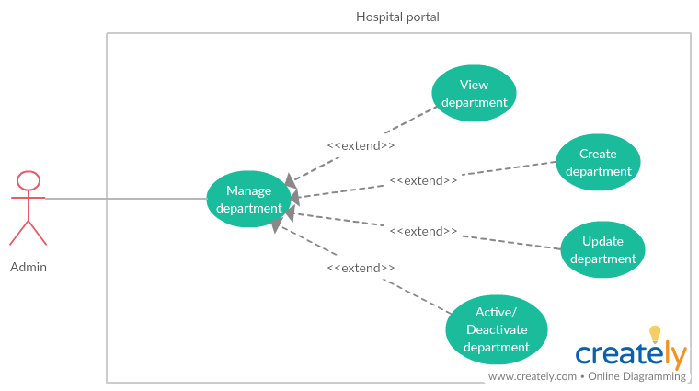

***2.3.1.2.1 <Admin> View department***

|  |  |  |  |
| --- | --- | --- | --- |
| **USE CASE -** UC_HP05 | | | |
| **Use Case No.** | UC_HP05 | **Use Case Version** | 2.0 |
| **Use Case Name** | View Department | | |
| **Author** | LinhTP | | |
| **Date** | 20/1/2018 | **Priority** | Normal |
| **Actor:**   * Admin.   **Summary:**   * This use case allows admin to view Department and username of user in Department.   **Goal:**   * Admin can view Department and user in Department.   **Triggers:**   * Admin click “View” Icon.   **Preconditions:**   * System had connected to database. * User login with role Admin.   **Post Conditions:**   * **Success:** System show all user in the selected specially * **Fail:** System display “Error” message.   **Main Success Scenario:**   |  |  |  | | --- | --- | --- | | Step | Actor Action | System Response | | 1 | Admin click tag [Manage Department] on menu bar. | System move to interface, where show all Department in list.  On each row there are:  - Name  - Code.  - Quantity  - Status  -View icon.  [**Alternative 1]** | | 2 | Admin click [View] icon on selected user row | System show user detail page.  On Department information page:   * Department name: * Department code: * Description |   **Alternative Scenario:**   |  |  |  | | --- | --- | --- | | No | Actor Action | System Response | | 1 | There is no Department in the data | Show label massager “There is no Department in the data”. |   **Exceptions:**   |  |  |  | | --- | --- | --- | | No | Actor Action | System Response | | 1 | Disconnect to server | System show message the “Connection to the server has been lost. Please check your internet connection or try again later. ” when the internet is lost |   **Relationships:** N/A  **Business Rules:**  **-**The Department must show correctly  -The page must have good design | | | |

***2.3.1.2.2 <Admin> Create department***

|  |  |  |  |
| --- | --- | --- | --- |
| **USE CASE -** UC_HP06 | | | |
| **Use Case No.** | UC_HP06 | **Use Case Version** | 2.0 |
| **Use Case Name** | Create Department | | |
| **Author** | LinhTP | | |
| **Date** | 20/1/2018 | **Priority** | Normal |
| **Actor:**   * Admin.   **Summary:**   * This use case allows admin to create new Department. * **Goal:** * Admin can create a Department.   **Triggers:**   * Admin click “Create new Department” button.   **Preconditions:**   * System had connected to database. * User login with role Admin.   **Post Conditions:**   * **Success:** A new Department created. * **Fail:** System display “Error” message.   **Main Success Scenario:**   |  |  |  | | --- | --- | --- | | Step | Actor Action | System Response | | 1 | Admin click tag [Manage Department] on menu bar. | System move to interface, where show all Department in list.  On each row there are:  - Name  - Code.  - Quantity  - Status  -View icon.  [**Alternative 1]** | | 2 | Admin click [Add] button. | System show create Department page with category info input form:  Department name (require): textbox, up to 512 characters long.  Department code (required): textbox, up to 10 character long.  Description: text area. | | 3 | Admin input Department information in create form.  Admin click [Save] button | [**Alternative 2]**  [**Alternative 3]**  Department will be create on data. Appears “Success” message.  Back to Department list |   **Alternative Scenario:**   |  |  |  | | --- | --- | --- | | No | Actor Action | System Response | | 1 | There is no Department in the data | Show label massager “There is no Department in the data”. | | 2 | This Department name is existed | Appears “Name existed.” Message. | | 3 | This Department code is existed | Appears “Code existed.” Message. |   **Exceptions:**   |  |  |  | | --- | --- | --- | | No | Actor Action | System Response | | 1 | Disconnect to server | System show message the “Connection to the server has been lost. Please check your internet connection or try again later. ” when the internet is lost |   **Relationships:** N/A  **Business Rules:**  **-**The Department must show correctly  -The page must have good design | | | |

***2.3.1.2.3 <Admin> Update department***

|  |  |  |  |
| --- | --- | --- | --- |
| **USE CASE -** UC_HP07 | | | |
| **Use Case No.** | UC_HP07 | **Use Case Version** | 2.0 |
| **Use Case Name** | Update Department | | |
| **Author** | LinhTP | | |
| **Date** | 20/1/2018 | **Priority** | Normal |
| **Actor:**   * Admin.   **Summary:**   * This use case allows admin to update a Department.   **Goal:**   * Admin can update a Department.   **Triggers:**   * Admin click [update] icon.   **Preconditions:**   * System had connected to database. * User login with role Admin.   **Post Conditions:**   * **Success:** A Department updated. * **Fail:** System display “Error” message.   **Main Success Scenario:**   |  |  |  | | --- | --- | --- | | Step | Actor Action | System Response | | 1 | Admin click tag [Manage Department] on menu bar. | System move to interface, where show all Department in list.  On each row there are:  - Name  - Code.  - Quantity  - Status  -View icon.  [**Alternative 1]** | | 2 | Admin click [View] icon | System show update Department page with category info load from database:  Department name (require): textbox, up to 512 characters long.  Department code (required): textbox, up to 10 character long.  Description: text area.  [**Alternative 2]** | | 3 | Admin input Department information in update form.  Admin click [save] button | [**Alternative 3]**  Department will be create on data. Appears “Success” message.  Back to Department list  [**Alternative 4]** |   **Alternative Scenario:**   |  |  |  | | --- | --- | --- | | No | Actor Action | System Response | | 1 | There is no Department in the data | Show label massager “There is no Department in the data”. | | 2 | Admin click [Back] button | Back to department list page. | | 3 | This Department name is existed | Appears “Name exited.” Message. | | 4 | This Department code is existed | Appears “Code exited.” Message. |   **Exceptions:**   |  |  |  | | --- | --- | --- | | No | Actor Action | System Response | | 1 | Disconnect to server | System show message the “Connection to the server has been lost. Please check your internet connection or try again later. ” when the internet is lost |   **Relationships:** N/A  **Business Rules:**  **-**The Department must show correctly  -The page must have good design | | | |

***2.3.1.2.4 <Admin> Activate /Deactivate department***

|  |  |  |  |
| --- | --- | --- | --- |
| **USE CASE -** UC_HP08 | | | |
| **Use Case No.** | UC_HP08 | **Use Case Version** | 2.0 |
| **Use Case Name** | Activate /Deactivate Department | | |
| **Author** | LinhTP | | |
| **Date** | 20/1/2018 | **Priority** | Normal |
| **Actor:**   * Admin.   **Summary:**   * This use case allows admin to Activate /deactivate Department.   **Goal:**   * Admin can Activate /deactivate Department.   **Triggers:**   * Admin click “Activate /Deactivate” Icon.   **Preconditions:**   * User login with role Admin. * System had connected to database. * This Department is Activate /deactivate.   **Post Conditions:**   * **Success:** Department is Deactivate * **Fail:** System display “Error” message.   **Main Success Scenario:**   |  |  |  | | --- | --- | --- | | Step | Actor Action | System Response | | 1 | Admin click tag [Manage Department] on menu bar. | System move to interface, where show all Department in list.  On each row there are:  - Name  - Code.  - Quantity  - Status  -View icon.  [**Alternative 1]**  [**Alternative 2]** | | 2 | Admin click [Activate /Deactivate] button on selected Department row | Category is Activate /deactivate on data. Appears “Success” message.  Back to category list  [**Alternative 3]** | | 3 | Admin click [yes] button |  |   **Alternative Scenario:**   |  |  |  | | --- | --- | --- | | No | Actor Action | System Response | | 1 | There is no Department in the data | Show label massager “There is no Department in the data”. | | 2 | This Department has some activate user | Show label massager “Can’t disable this department. There are Activate account in this department”.  Department no change. |   **Exceptions:**   |  |  |  | | --- | --- | --- | | No | Actor Action | System Response | | 1 | Disconnect to server | System show message the “Connection to the server has been lost. Please check your internet connection or try again later. ” when the internet is lost |   **Relationships:** N/A  **Business Rules:**  **-**The Department must show correctly  -The page must have good design | | | |

***2.3.1.3 <Admin> Manage room resource***

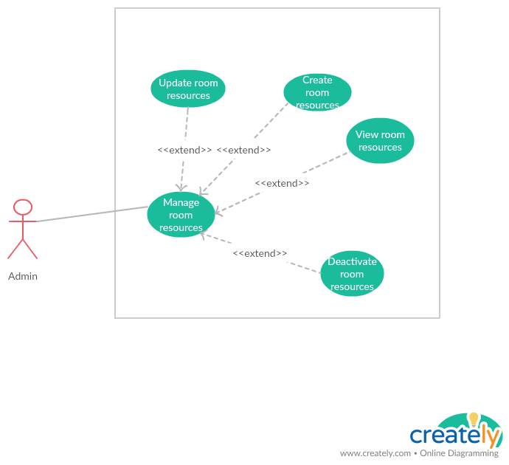

***2.3.1.3.1 <Admin> View room resource***

|  |  |  |  |
| --- | --- | --- | --- |
| **USE CASE -** UC_HP09 | | | |
| **Use Case No.** | UC_HP09 | **Use Case Version** | 2.0 |
| **Use Case Name** | View room resources | | |
| **Author** | LinhTP | | |
| **Date** | 20/1/2018 | **Priority** | Normal |
| **Actor:**   * Admin.   **Summary:**   * This use case allows admin to view room resources information.   **Goal:**   * Admin can view room resources information.   **Triggers:**   * Admin click “View” Icon.   **Preconditions:**   * User login with role Admin. * System had connected to database.   **Post Conditions:**   * **Success:** System show resources information * **Fail:** System display “Error” message.   **Main Success Scenario:**   |  |  |  | | --- | --- | --- | | Step | Actor Action | System Response | | 1 | Admin click tag [Manage room] on menu bar. | System move to Manage room resources interface, where show all meeting room in list.  On each row there are:  -Room name  -Room size (max people).  -Status  -View icon.  [**Alternative 1]** | | 2 | Admin click [View] icon on selected user row | System show room detail popup.  On popup is room information:  Room name  Room size |   **Alternative Scenario:**   |  |  |  | | --- | --- | --- | | No | Actor Action | System Response | | 1 | There is no room in the data | Show label massager “There is no room in the data”. |   **Exceptions:**   |  |  |  | | --- | --- | --- | | No | Actor Action | System Response | | 1 | Disconnect to server | System show message the “Connection to the server has been lost. Please check your internet connection or try again later. ” when the internet is lost |   **Relationships:** N/A  **Business Rules:**  **-**The room must show correctly  -The page must have good design | | | |

***2.3.1.3.2 <Admin> Create room resource***

|  |  |  |  |
| --- | --- | --- | --- |
| **USE CASE -** UC_HP10 | | | |
| **Use Case No.** | UC_HP10 | **Use Case Version** | 2.0 |
| **Use Case Name** | Create room resources | | |
| **Author** | LinhTP | | |
| **Date** | 20/1/2018 | **Priority** | Normal |
| **Actor:**   * Admin.   **Summary:**   * This use case allows admin to create new room resources.   **Goal:**   * Admin can create a room resources.   **Triggers:**   * Admin click “Add” button.   **Preconditions:**   * User login with role Admin. * System had connected to database.   **Post Conditions:**   * **Success:** A new room created. * **Fail:** System display “Error” message.   **Main Success Scenario:**   |  |  |  | | --- | --- | --- | | Step | Actor Action | System Response | | 1 | Admin click tag [Manage room] on menu bar. | System move to Manage room resources interface, where show all meeting room in list.  On each row there are:  -Room name  -Room size (max people).  -Status  -View icon.  [**Alternative 1]** | | 2 | Admin click [Add] button. | System show create room page with room info input form:  Room name (require): textbox, up to 512 characters long.  Room size (max people). Input number. | | 3 | Admin input room information in create form.  Admin click [Save] button | New room will be create on data. Appears “Success” message.  Back to room list  [**Alternative 2]** |   **Alternative Scenario:**   |  |  |  | | --- | --- | --- | | No | Actor Action | System Response | | 1 | There is no room in the data | Show label massager “There is no room in the data”. | | 2 | Admin click “Back” button | Back to room list page |   **Exceptions:**   |  |  |  | | --- | --- | --- | | No | Actor Action | System Response | | 1 | Disconnect to server | System show message the “Connection to the server has been lost. Please check your internet connection or try again later. ” when the internet is lost |   **Relationships:** N/A  **Business Rules:**  **-**The room must show correctly  -The page must have good design | | | |

***2.3.1.3.3 <Admin> Update room resource***

|  |  |  |  |
| --- | --- | --- | --- |
| **USE CASE -** UC_HP11 | | | |
| **Use Case No.** | UC_HP11 | **Use Case Version** | 2.0 |
| **Use Case Name** | Update room resources | | |
| **Author** | LinhTP | | |
| **Date** | 20/1/2018 | **Priority** | Normal |
| **Actor:**   * Admin.   **Summary:**   * This use case allows admin to update a room resources information.   **Goal:**   * Admin can create a room resources.   **Triggers:**   * Admin click [View] icon   **Preconditions:**   * User login with role Admin. * System had connected to database.   **Post Conditions:**   * **Success:** Room updated. * **Fail:** System display “Error” message.   **Main Success Scenario:**   |  |  |  | | --- | --- | --- | | Step | Actor Action | System Response | | 1 | Admin click tag [Manage room] on menu bar. | System move to Manage room resources interface, where show all meeting room in list.  On each row there are:  -Room name  -Room size (max people).  -Status  -View icon.  [**Alternative 1]** | | 2 | Admin click [update] icon on selected room row | System show update room popup with room information load from database:  Room name (require): textbox, up to 512 characters long.  Room size (max people). Input number. | | 3 | Admin input room information in create form.  Admin click [Save] button | Room will be create on data. Appears “Success” message.  Back to room list  [**Alternative 2]** |   **Alternative Scenario:**   |  |  |  | | --- | --- | --- | | No | Actor Action | System Response | | 1 | There is no room in the data | Show label massager “There is no room in the data”. | | 2 | Admin click “Back” button | Back to room list page |   **Exceptions:**   |  |  |  | | --- | --- | --- | | No | Actor Action | System Response | | 1 | Disconnect to server | System show message the “Connection to the server has been lost. Please check your internet connection or try again later. ” when the internet is lost |   **Relationships:** N/A  **Business Rules:**  **-**The room must show correctly  -The page must have good design | | | |

***2.3.1.3.1 <Admin> Activate /Deactivate room resource***

|  |  |  |  |
| --- | --- | --- | --- |
| **USE CASE -** UC_HP12 | | | |
| **Use Case No.** | UC_HP12 | **Use Case Version** | 2.0 |
| **Use Case Name** | Activate /Deactivate room resources | | |
| **Author** | LinhTP | | |
| **Date** | 20/1/2018 | **Priority** | Normal |
| **Actor:**   * Admin.   **Summary:**   * This use case allows admin to Activate /deactivate room.   **Goal:**   * Admin can Activate /deactivate room.   **Triggers:**   * Admin click “Activate /Deactivate” button.   **Preconditions:**   * User login with role Admin. * System had connected to database. * This room is Activate /deactivate.   **Post Conditions:**   * **Success:** room is Activate /Deactivate * **Fail:** System display “Error” message.   **Main Success Scenario:**   |  |  |  | | --- | --- | --- | | Step | Actor Action | System Response | | 1 | Admin click tag [Manage room] on menu bar. | System move to Manage room resources interface, where show all meeting room in list.  On each row there are:  -Room name  -Room size (max people).  -Status  -View icon.  [**Alternative 1]** | | 2 | Admin click [Activate /Deactivate] button on selected room row | Category is deactivate on data. Appears “Success” message.  Back to category list  [**Alternative 2]** |   **Alternative Scenario:**   |  |  |  | | --- | --- | --- | | No | Actor Action | System Response | | 1 | There is no room in the data | Show label massager “There is no room in the data”. | | 2 | Admin click “Back” button | Back to room list page. |   **Exceptions:**   |  |  |  | | --- | --- | --- | | No | Actor Action | System Response | | 1 | Disconnect to server | System show message the “Connection to the server has been lost. Please check your internet connection or try again later. ” when the internet is lost |   **Relationships:** N/A  **Business Rules:**  **-**The room must show correctly  -The page must have good design | | | |

***2.3.2 <Manager>Overview Use Case***

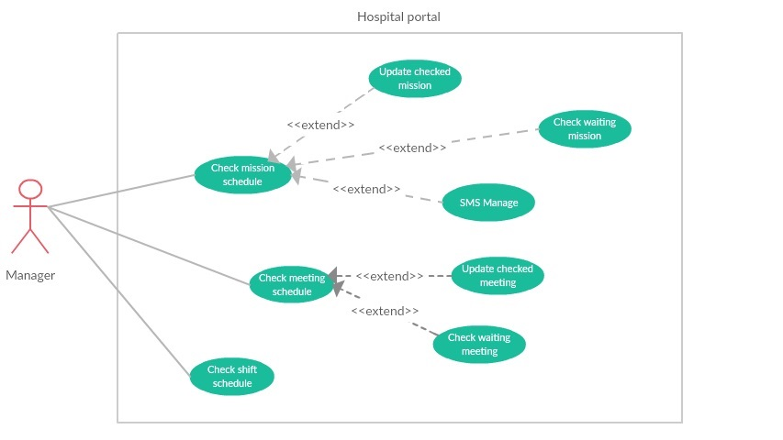

***2.3.2.1 <Manager> Check mission schedule***

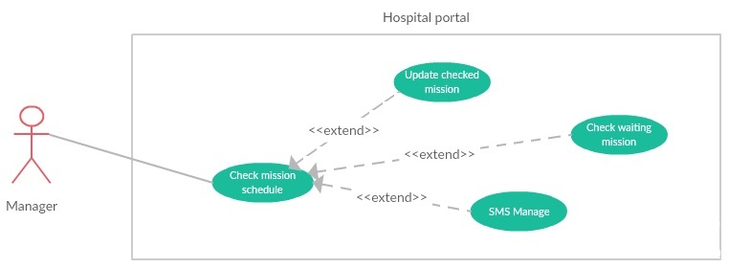

***2.3.2.1.1 <Manager> Check waiting mission***

|  |  |  |  |
| --- | --- | --- | --- |
| **USE CASE -** UC_HP13 | | | |
| **Use Case No.** | UC_HP13 | **Use Case Version** | 2.0 |
| **Use Case Name** | Check waiting mission | | |
| **Author** | LongHH | | |
| **Date** | 13/1/2018 | **Priority** | Normal |
| **Actor:**   * Manager.   **Summary:**   * This use case allows manager to check mission schedule.   **Goal:**   * Manager can check mission schedule.   **Triggers:**   * Manager sends command to check mission schedule.   **Preconditions:**   * User must login into the system with role Manager. * Mission status is waiting.   **Post Conditions:**   * **Success:** Manager could check mission schedule successfully. * **Fail:** System display “Error” message.   **Main Success Scenario:**   |  |  |  | | --- | --- | --- | | Step | Actor Action | System Response | | 1 | Manager goes to manage mission schedule page. | Display 2 tabs (waiting and checked), in each tab:  Display mission list in table if system has any mission schedule to manage.  On each row there are:   * Start date * End date * Place * Worker * Status * Update button | | 2 | Manager click on “Waiting Mission” tab to view uncheck missions. | Display table of uncheck mission | | 3 | Manager click on “Waiting” button and select “Accept” if the mission schedule is appropriate.  [**Alternative 1]** | Mission status change to Accept, Mission upload to portal  System send SMS to all user in worker list to notify. |   **Alternative Scenario:**   |  |  |  | | --- | --- | --- | | No | Actor Action | System Response | | 1 | Manager click on “Waiting” button and select “Deny” if the mission schedule is inappropriate. | The status of mission change to “Denied”. |   **Exceptions:**   |  |  |  | | --- | --- | --- | | No | Actor Action | System Response | | 1 | Disconnect to server. | System show message the “Connection to the server has been lost. Please check your internet connection or try again later.” when the internet is lost. |   **Relationships:** N/A  **Business Rules:**   * Worker in list will be received SMS by the phone number in account. | | | |

***2.3.2.1.2 <Manager> Update checked mission***

|  |  |  |  |
| --- | --- | --- | --- |
| **USE CASE -** UC_HP14 | | | |
| **Use Case No.** | UC_HP14 | **Use Case Version** | 2.0 |
| **Use Case Name** | Update checked mission | | |
| **Author** | LongHH | | |
| **Date** | 13/1/2018 | **Priority** | Normal |
| **Actor:**   * Manager.   **Summary:**   * This use case allows manager to update checked mission schedule status.   **Goal:**   * Mission schedule status was updated.   **Triggers:**   * Manager sends command to update mission schedule status.   **Preconditions:**   * User must login into the system with role Manager. * Mission was checked (status is Accept or Deny)   **Post Conditions:**   * **Success:** Mission schedule status updated successfully. * **Fail:** System display “Error” message.   **Main Success Scenario:**   |  |  |  | | --- | --- | --- | | Step | Actor Action | System Response | | 1 | Manager goes to manage mission schedule page. | Display 2 tabs (waiting and checked), in each tab:  Display mission list in table if system has any mission schedule to manage.  On each row there are:   * Start date * End date * Place * Worker * Status * Update button | | 2 | Manager click on “Checked Mission” tab to view uncheck missions. | Display table of checked mission | | 3 | Manager click on “Deny” button and select “Accept” if the mission schedule is appropriate.  [**Alternative 1]**  [**Alternative 2]** | Mission status change to Accept, Mission upload to portal  System send SMS to all user in worker list to notify. | |  |  |  |   **Alternative Scenario:**   |  |  |  | | --- | --- | --- | | No | Actor Action | System Response | | 1 | Manager click on “Accept” button and select “Deny” if the mission schedule is inappropriate. | The status of mission change to “Denied”.  Mission hidden from the portal.  System send SMS to all user in worker list to notify. | | 2 | Manager click on “No” button | The status not change. |   **Exceptions:**   |  |  |  | | --- | --- | --- | | No | Actor Action | System Response | | 1 | Disconnect to server. | System show message the “Connection to the server has been lost. Please check your internet connection or try again later.” when the internet is lost. |   **Relationships:** N/A  **Business Rules:**   * Worker in list will be received SMS by the phone number in account. | | | |

***2.3.2.2 <Manager> Check meeting schedule***

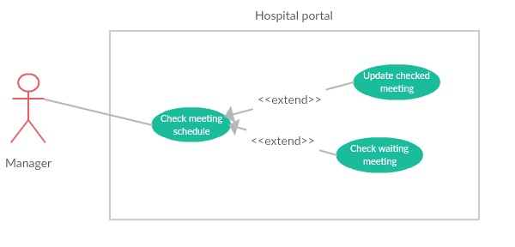

***2.3.2.2.1 <Manager> Check waiting meeting***

|  |  |  |  |
| --- | --- | --- | --- |
| **USE CASE -** UC_HP15 | | | |
| **Use Case No.** | UC_HP15 | **Use Case Version** | 2.0 |
| **Use Case Name** | Check waiting meeting | | |
| **Author** | LongHH | | |
| **Date** | 13/1/2018 | **Priority** | Normal |
| **Actor:**   * Manager.   **Summary:**   * This use case allows manager to check meeting schedule.   **Goal:**   * Manager can check meeting schedule.   **Triggers:**   * Manager sends command to check meeting schedule.   **Preconditions:**   * User must login into the system with role Manager. * Meeting status is waiting.   **Post Conditions:**   * **Success:** Manager could check meeting schedule successfully. * **Fail:** System display “Error” message.   **Main Success Scenario:**   |  |  |  | | --- | --- | --- | | Step | Actor Action | System Response | | 1 | Manager goes to manage meeting schedule page. | Display 2 tabs (waiting and checked), in each tab:  Display mission list in table if system has any meeting schedule to manage.  On each row there are:   * Meeting name * Room * Date * Start time * Duration * Status * Update button | | 2 | Manager click on “Waiting Meeting” tab to view uncheck meeting. | Display table of uncheck meeting | | 3 | Manager click on “Waiting” button and select “Accept” if the meeting schedule is appropriate.  [**Alternative 1]** | Meeting status change to Accept, Meeting upload to portal. |   **Alternative Scenario:**   |  |  |  | | --- | --- | --- | | No | Actor Action | System Response | | 1 | Manager click on “Waiting” button and select “Deny” if the meeting schedule is inappropriate. | The status of meeting change to “Denied”. |   **Exceptions:**   |  |  |  | | --- | --- | --- | | No | Actor Action | System Response | | 1 | Disconnect to server. | System show message the “Connection to the server has been lost. Please check your internet connection or try again later.” when the internet is lost. |   **Relationships:** N/A  **Business Rules:** | | | |

***2.3.2.2.2 <Manager> Update checked meeting***

|  |  |  |  |
| --- | --- | --- | --- |
| **USE CASE -** UC_HP16 | | | |
| **Use Case No.** | UC_HP16 | **Use Case Version** | 2.0 |
| **Use Case Name** | Update checked meeting | | |
| **Author** | LongHH | | |
| **Date** | 13/1/2018 | **Priority** | Normal |
| **Actor:**   * Manager.   **Summary:**   * This use case allows manager to update checked meeting schedule status.   **Goal:**   * Meeting schedule status was updated.   **Triggers:**   * Manager sends command to check meeting schedule.   **Preconditions:**   * User must login into the system with role Manager. * Meeting is checked (status is Accept or Deny).   **Post Conditions:**   * **Success:** Meeting schedule status updated successfully**.** * **Fail:** System display “Error” message.   **Main Success Scenario:**   |  |  |  | | --- | --- | --- | | Step | Actor Action | System Response | | 1 | Manager goes to manage meeting schedule page. | Display 2 tabs (waiting and checked), in each tab:  Display mission list in table if system has any meeting schedule to manage.  On each row there are:   * Meeting name * Room * Date * Start time * Duration * Status * Update button | | 2 | Manager click on “Checked Meeting” tab to view uncheck meeting. | Display table of uncheck meeting | | 3 | Manager click on “Deny” button and select “Accept” if the meeting schedule is appropriate.  [**Alternative 1]**  [**Alternative 2]** | Meeting status change to Accept, Meeting upload to portal. |   **Alternative Scenario:**   |  |  |  | | --- | --- | --- | | No | Actor Action | System Response | | 1 | Manager click on “Accept” button and select “Deny” if the meeting schedule is inappropriate. | The status of meeting change to “Denied”.  Meeting hidden from the portal. | | 2 | Manager click on “No” button | The status not change. |   **Exceptions:**   |  |  |  | | --- | --- | --- | | No | Actor Action | System Response | | 1 | Disconnect to server. | System show message the “Connection to the server has been lost. Please check your internet connection or try again later.” when the internet is lost. |   **Relationships:** N/A  **Business Rules:** | | | |

***2.3.2.3 <Manager> Check shift schedule***

|  |  |  |  |
| --- | --- | --- | --- |
| **USE CASE -** UC_HP17 | | | |
| **Use Case No.** | UC_HP17 | **Use Case Version** | 2.0 |
| **Use Case Name** | Check shift schedule | | |
| **Author** | LongHH | | |
| **Date** | 13/1/2018 | **Priority** | Normal |
| **Actor:**   * Manager.   **Summary:**   * This use case allows manager to check shift schedule.   **Goal:**   * Manager can check shift schedule.   **Triggers:**   * Manager sends command to check shift schedule.   **Preconditions:**   * User must login into the system with role Manager. * The waiting shift schedule status is uncheck.   **Post Conditions:**   * **Success:** Manager could shift meeting schedule successfully. * **Fail:** System display “Error” message.   **Main Success Scenario:**   |  |  |  | | --- | --- | --- | | Step | Actor Action | System Response | | 1 | Manager goes to manage shift schedule page and select Department. | Display 3 tabs (“In coming”, “Quick search” and “Pass”), in each tab:  Display shift schedule manage panel of this department in timeline list.  On each panel there are:   * Start day –End day. * Waiting schedule and status button. * Posted schedule and status button. | | 2 | Manager select the “Waiting : uncheck” scheduler button | Display uncheck shift scheduler | | 3 | Manager click on “Waiting” button and select “Accept” if the shift schedule is appropriate.  [**Alternative 1]** | Posted Shift schedule = Waiting Shift schedule  Waiting and posted status change to “posted”. |   **Alternative Scenario:**   |  |  |  | | --- | --- | --- | | No | Actor Action | System Response | | 1 | Manager click on “Waiting” button and select “Deny” if the meeting schedule is inappropriate. | Waiting Shift schedule = Posted Shift schedule  Waiting Shift schedule status = Posted Shift schedule status |   **Exceptions:**   |  |  |  | | --- | --- | --- | | No | Actor Action | System Response | | 1 | Disconnect to server. | System show message the “Connection to the server has been lost. Please check your internet connection or try again later.” when the internet is lost. |   **Relationships:** N/A  **Business Rules:** | | | |

***2.3.3 <Scheduler>Overview Use Case***

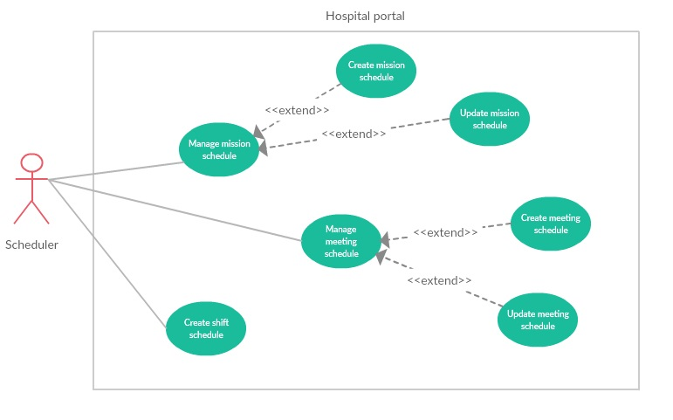

***2.3.3.1 < Scheduler > Create shift schedule***

|  |  |  |  |
| --- | --- | --- | --- |
| **USE CASE -** UC_HP18 | | | |
| **Use Case No.** | UC_HP18 | **Use Case Version** | 2.0 |
| **Use Case Name** | Create Shift Schedule | | |
| **Author** | LongHH | | |
| **Date** | 13/1/2018 | **Priority** | Normal |
| **Actor:**   * Manager/Scheduler.   **Summary:**   * This use case allows Manager/Scheduler to create Shift Scheduler.   **Goal:**   * Manager/Scheduler can create a Shift Scheduler.   **Triggers:**   * Manager/Scheduler sends command to create a Shift Scheduler.   **Preconditions:**   * User must login into the system with role Manager or Scheduler.   **Post Conditions:**   * **Success:** Manager/Scheduler could create Shift Scheduler successfully. * **Fail:** System display “Error” message.   **Main Success Scenario:**   |  |  |  | | --- | --- | --- | | Step | Actor Action | System Response | | 1 | Manager/Scheduler goes to manage shift schedule page. | Display 3 tabs (“In coming”, “Quick search” and “Pass”), in each tab:  Display shift schedule manage panel of this department in timeline list.  On each panel there are:   * Start day –End day. * Waiting schedule and status button. * Posted schedule and status button. | | 2 | Manager/Scheduler select the “Create new scheduler” button | Display create new shift scheduler page | | 3 | Manager/Scheduler select Department, Employee per shift number and week | System validate and create the schedule | | 4 | Manager/Scheduler select Start time and End time and click “+” button to add shift. | System validate and add more shift to every date in scheduler. | | 5 | Manager/Scheduler select employees in every shift | System validate and activate “Finish” button. | | 6 | Manager/Scheduler click “Finish” button. | Shift schedule save to schedule manage waiting by status uncheck. |   **Alternative Scenario:**   |  |  |  | | --- | --- | --- | | No | Actor Action | System Response | |  |  |  |   **Exceptions:**   |  |  |  | | --- | --- | --- | | No | Actor Action | System Response | | 1 | Disconnect to server. | System show message the “Connection to the server has been lost. Please check your internet connection or try again later.” when the internet is lost. | | 2 | Department not selected | Department label background change to red, deactivate finish button. | | 3 | Week not selected | Week label background change to red, deactivate finish button. | | 4 | Employee per shift invalid | Employee per shift label background change to red, deactivate finish button. | |  |  |  |   **Relationships:** N/A  **Business Rules:**   * Worker in list will be received SMS by the phone number in account. | | | |

***2.3.3.2 < Scheduler > Manage mission schedule***

***2.3.3.2.1 <Scheduler> Create mission schedule***

|  |  |  |  |
| --- | --- | --- | --- |
| **USE CASE -** UC_HP19 | | | |
| **Use Case No.** | UC_HP19 | **Use Case Version** | 2.0 |
| **Use Case Name** | Create mission schedule | | |
| **Author** | LongHH | | |
| **Date** | 20/1/2018 | **Priority** | Normal |
| **Actor:**   * Manager, scheduler.   **Summary:**   * This use case allows manager/scheduler to create new mission schedule.   **Goal:**   * Manager/scheduler can create new mission schedule.   **Triggers:**   * Manager/scheduler click “Add” button.   **Preconditions:**   * User login with role Manager/Scheduler. * System had connected to database.   **Post Conditions:**   * **Success:** Mission schedule is created completely. * **Fail:** System display “Error” message.   **Main Success Scenario:**   |  |  |  | | --- | --- | --- | | Step | Actor Action | System Response | | 1 | Manager/scheduler click tag [Manage mission schedule] on menu bar. | System move to Manage mission schedule interface, where show all mission schedule in list.  On each row there are:  -Start date  -End date  -Place  -Worker  -Status  -View icon.  [**Alternative 1]** | | 2 | Manager/scheduler click [Add] button. | System show create mission schedule page with mission schedule info input form:   * Member (required): Multiple choice dropdown list. * Start date (required): Date picker. * End date (required): Date picker * Place (required): input text * Content (required): input text (up to 512 characters long) * Note: text area (up to 512 characters long) | | 3 | Manager/scheduler input mission information in create form.  Manager/scheduler click [Save] button | Mission will be create on data. Appears “Success” message.  Back to mission list  [**Alternative 2]** |   **Alternative Scenario:**   |  |  |  | | --- | --- | --- | | No | Actor Action | System Response | | 1 | There is no mission schedule in the data | Show label massager “There is no mission schedule in the data”. | | 2 | Manager/scheduler click “Back” button | Back to mission schedule list page. |   **Exceptions:**   |  |  |  | | --- | --- | --- | | No | Actor Action | System Response | | 1 | Disconnect to server | System show message the “Connection to the server has been lost. Please check your internet connection or try again later. ” when the internet is lost |   **Relationships:** N/A  **Business Rules:**  **-**The mission schedule must show correctly  -The page must have good design | | | |

***2.3.3.2.2 <Scheduler> Update mission schedule***

|  |  |  |  |
| --- | --- | --- | --- |
| **USE CASE -** UC_HP20 | | | |
| **Use Case No.** | UC_HP20 | **Use Case Version** | 2.0 |
| **Use Case Name** | Update mission schedule | | |
| **Author** | LongHH | | |
| **Date** | 20/1/2018 | **Priority** | Normal |
| **Actor:**   * Manager, scheduler.   **Summary:**   * This use case allows manager/scheduler to update mission schedule.   **Goal:**   * Manager/scheduler can update mission schedule.   **Triggers:**   * Manager/scheduler click “View” icon.   **Preconditions:**   * User login with role Manager/Scheduler. * System had connected to database.   **Post Conditions:**   * **Success:** Mission schedule is updated completely. * **Fail:** System display “Error” message.   **Main Success Scenario:**   |  |  |  | | --- | --- | --- | | Step | Actor Action | System Response | | 1 | Manager/scheduler click tag [Manage mission schedule] on menu bar. | System move to Manage mission schedule interface, where show all mission schedule in list.  On each row there are:  -Start date  -End date  -Place  -Worker  -Status  -View icon.  [**Alternative 1]** | | 2 | Manager/scheduler click [View] icon. | System show update mission schedule page with mission schedule info input form:   * Member (required): Multiple choice dropdown list. * Start date (required): Date picker. * End date (required): Date picker * Place (required): input text * Content (required): input text (up to 512 characters long) * Note: text area (up to 512 characters long) | | 3 | Manager/scheduler input mission information in create form.  Manager/scheduler click [Save] button | Mission will be create on data. Appears “Success” message.  Back to mission list  [**Alternative 2]** |   **Alternative Scenario:**   |  |  |  | | --- | --- | --- | | No | Actor Action | System Response | | 1 | There is no mission schedule in the data | Show label massager “There is no mission schedule in the data”. | | 2 | Manager/scheduler click “Back” button | Back to mission schedule list page. |   **Exceptions:**   |  |  |  | | --- | --- | --- | | No | Actor Action | System Response | | 1 | Disconnect to server | System show message the “Connection to the server has been lost. Please check your internet connection or try again later. ” when the internet is lost |   **Relationships:** N/A  **Business Rules:**  **-**The mission schedule must show correctly  -The page must have good design | | | |

***2.3.3.3 < Scheduler > Manage meeting schedule***

***2.3.3.3.1 <Scheduler> Create meeting schedule***

|  |  |  |  |
| --- | --- | --- | --- |
| **USE CASE -** UC_HP21 | | | |
| **Use Case No.** | UC_HP21 | **Use Case Version** | 2.0 |
| **Use Case Name** | Create meeting schedule | | |
| **Author** | LongHH | | |
| **Date** | 20/1/2018 | **Priority** | Normal |
| **Actor:**   * Manager, scheduler.   **Summary:**   * This use case allows manager/scheduler to create new meeting schedule.   **Goal:**   * Manager/scheduler can create new meeting schedule.   **Triggers:**   * Manager/scheduler click “Add” button.   **Preconditions:**   * User login with role Manager/Scheduler. * System had connected to database.   **Post Conditions:**   * **Success:** Meeting schedule is created completely. * **Fail:** System display “Error” message.   **Main Success Scenario:**   |  |  |  | | --- | --- | --- | | Step | Actor Action | System Response | | 1 | Manager/scheduler click tag [Manage meeting schedule] on menu bar. | System move to Manage meeting schedule interface, where show all meeting schedule in list.  On each row there are:  -Meeting name  -Room  -Date  -Start time  -End time  -Status  -View icon.  [**Alternative 1]** | | 2 | Manager/scheduler click [Add] button. | System show create meeting schedule page with meeting schedule info input form:   * Meeting name(required): input text (up to 256 characters long) * Room(required): Dropdown list * Start time (required): Time picker. * End time (required): Time picker * Date (required): Date picker * Content (required): input text (up to 512 characters long) * Note: text area (up to 512 characters long) | | 3 | Manager/scheduler input meeting information in create form.  Manager/scheduler click [Save] button | Meeting will be create on data. Appears “Success” message.  Back to meeting list  [**Alternative 2]** |   **Alternative Scenario:**   |  |  |  | | --- | --- | --- | | No | Actor Action | System Response | | 1 | There is no meeting schedule in the data | Show label massager “There is no meeting schedule in the data”. | | 2 | Manager/scheduler click “Back” button | Back to meeting schedule list page. |   **Exceptions:**   |  |  |  | | --- | --- | --- | | No | Actor Action | System Response | | 1 | Disconnect to server | System show message the “Connection to the server has been lost. Please check your internet connection or try again later. ” when the internet is lost |   **Relationships:** N/A  **Business Rules:**  **-**The meeting schedule must show correctly  -The page must have good design | | | |

***2.3.3.3.2 <Scheduler> Update meeting schedule***

|  |  |  |  |
| --- | --- | --- | --- |
| **USE CASE -** UC_HP22 | | | |
| **Use Case No.** | UC_HP22 | **Use Case Version** | 2.0 |
| **Use Case Name** | Update meeting schedule | | |
| **Author** | LongHH | | |
| **Date** | 20/1/2018 | **Priority** | Normal |
| **Actor:**   * Manager, scheduler.   **Summary:**   * This use case allows manager/scheduler to update meeting schedule.   **Goal:**   * Manager/scheduler can update meeting schedule.   **Triggers:**   * Manager/scheduler click “Add” button.   **Preconditions:**   * User login with role Manager/Scheduler. * System had connected to database.   **Post Conditions:**   * **Success:** Meeting schedule is updated completely. * **Fail:** System display “Error” message.   **Main Success Scenario:**   |  |  |  | | --- | --- | --- | | Step | Actor Action | System Response | | 1 | Manager/scheduler click tag [Manage meeting schedule] on menu bar. | System move to Manage meeting schedule interface, where show all meeting schedule in list.  On each row there are:  -Meeting name  -Room  -Date  -Start time  -End time  -Status  -View icon.  [**Alternative 1]** | | 2 | Manager/scheduler click [View] button. | System show create meeting schedule page with meeting schedule info input form:   * Meeting name(required): input text (up to 256 characters long) * Room(required): Dropdown list * Start time (required): Time picker. * End time (required): Time picker * Date (required): Date picker * Content (required): input text (up to 512 characters long) * Note: text area (up to 512 characters long) | | 3 | Manager/scheduler input meeting information in update form.  Manager/scheduler click [Save] button | Meeting will be update on data. Appears “Success” message.  Back to meeting list  [**Alternative 2]** |   **Alternative Scenario:**   |  |  |  | | --- | --- | --- | | No | Actor Action | System Response | | 1 | There is no meeting schedule in the data | Show label massager “There is no meeting schedule in the data”. | | 2 | Manager/scheduler click “Back” button | Back to meeting schedule list page. |   **Exceptions:**   |  |  |  | | --- | --- | --- | | No | Actor Action | System Response | | 1 | Disconnect to server | System show message the “Connection to the server has been lost. Please check your internet connection or try again later. ” when the internet is lost |   **Relationships:** N/A  **Business Rules:**  **-**The meeting schedule must show correctly  -The page must have good design | | | |

***2.3.4 <User>Overview Use Case***

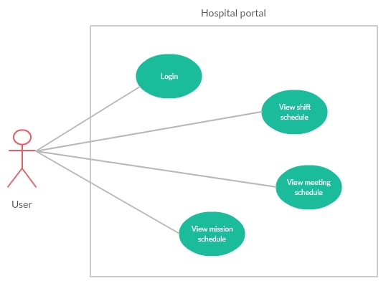

***2.3.4.1 < User> View shift schedule***

|  |  |  |  |
| --- | --- | --- | --- |
| **USE CASE -** UC_HP23 | | | |
| **Use Case No.** | UC_HP23 | **Use Case Version** | 2.0 |
| **Use Case Name** | View shift schedule | | |
| **Author** | LinhTP | | |
| **Date** | 20/1/2018 | **Priority** | Normal |
| **Actor:**   * User.   **Summary:**   * This use case allows user to view shift schedule.   **Goal:**   * User can view shift schedule.   **Triggers:**   * User click “Shift schedule” tag.   **Preconditions:**   * System had connected to database. * User login with role User.   **Post Conditions:**   * **Success:** System show shift schedule * **Fail:** System display “Error” message.   **Main Success Scenario:**   |  |  |  | | --- | --- | --- | | Step | Actor Action | System Response | | 1 | User click tag [Shift schedule] on menu bar. | System move to interface, where shift schedule is showed | | 2 | User choice department on dropdown list.  User choice week on dropdown list. | System show shift schedule detail of one week being filtered by department.  [**Alternative 1]** |   **Alternative Scenario:**   |  |  |  | | --- | --- | --- | | No | Actor Action | System Response | | 1 | There is no shift schedule in the data | Show label massager “This schedule is empty please select other schedule”. |   **Exceptions:**   |  |  |  | | --- | --- | --- | | No | Actor Action | System Response | | 1 | Disconnect to server | System show message the “Connection to the server has been lost. Please check your internet connection or try again later. ” when the internet is lost |   **Relationships:** N/A  **Business Rules:**  **-**The shift schedule must show correctly  -The page must have good design | | | |

***2.3.4.2 < User> View meeting schedule***

|  |  |  |  |
| --- | --- | --- | --- |
| **USE CASE -** UC_HP24 | | | |
| **Use Case No.** | UC_HP24 | **Use Case Version** | 2.0 |
| **Use Case Name** | View meeting schedule | | |
| **Author** | LinhTP | | |
| **Date** | 20/1/2018 | **Priority** | Normal |
| **Actor:**   * User.   **Summary:**   * This use case allows user to view meeting schedule.   **Goal:**   * User can view meeting schedule.   **Triggers:**   * User click “Meeting schedule” tag.   **Preconditions:**   * System had connected to database. * User login with role User.   **Post Conditions:**   * **Success:** System show meeting schedule * **Fail:** System display “Error” message.   **Main Success Scenario:**   |  |  |  | | --- | --- | --- | | Step | Actor Action | System Response | | 1 | User click tag [Meeting schedule] on menu bar. | System move to interface, where meeting schedule is showed  [**Alternative 1]** | | 2 | User click “In coming” tab  [**Alternative 2]**  [**Alternative 3]** | System show meeting schedule in the future. | | 3 | User click “View” button | System show detail of the meeting schedule. |   **Alternative Scenario:**   |  |  |  | | --- | --- | --- | | No | Actor Action | System Response | | 1 | There is no meeting schedule in the data | Show label massager “This schedule is empty please select other schedule”. | | 2 | User click “Quick search” tab | System show from date picker and to date picker to search meeting in range. | | 3 | User click “Pass” tab | System show meeting schedule in the pass. |   **Exceptions:**   |  |  |  | | --- | --- | --- | | No | Actor Action | System Response | | 1 | Disconnect to server | System show message the “Connection to the server has been lost. Please check your internet connection or try again later. ” when the internet is lost |   **Relationships:** N/A  **Business Rules:**  **-**The meeting must show correctly  -The page must have good design | | | |

***2.3.4.3 < User> View mission schedule***

|  |  |  |  |
| --- | --- | --- | --- |
| **USE CASE -** UC_HP25 | | | |
| **Use Case No.** | UC_HP25 | **Use Case Version** | 2.0 |
| **Use Case Name** | View mission schedule | | |
| **Author** | LinhTP | | |
| **Date** | 20/1/2018 | **Priority** | Normal |
| **Actor:**   * User.   **Summary:**   * This use case allows user to view mission schedule.   **Goal:**   * User can view mission schedule.   **Triggers:**   * User click “Mission schedule” tag.   **Preconditions:**   * System had connected to database. * User login with role User.   **Post Conditions:**   * **Success:** System show mission schedule * **Fail:** System display “Error” message.   **Main Success Scenario:**   |  |  |  | | --- | --- | --- | | Step | Actor Action | System Response | | 1 | User click tag [Mission schedule] on menu bar. | System move to interface, where mission schedule is showed  [**Alternative 1]** |   **Alternative Scenario:**   |  |  |  | | --- | --- | --- | | No | Actor Action | System Response | | 1 | There is no mission schedule in the data | Show label massager “You don't join in any mission”. |   **Exceptions:**   |  |  |  | | --- | --- | --- | | No | Actor Action | System Response | | 1 | Disconnect to server | System show message the “Connection to the server has been lost. Please check your internet connection or try again later. ” when the internet is lost |   **Relationships:** N/A  **Business Rules:**  **-**The mission must show correctly  -The page must have good design | | | |

***2.3.4.4 < User> Login***

|  |  |  |  |
| --- | --- | --- | --- |
| **USE CASE -** UC_HP26 | | | |
| **Use Case No.** | UC_HP26 | **Use Case Version** | 2.0 |
| **Use Case Name** | Login | | |
| **Author** | LinhTP | | |
| **Date** | 20/1/2018 | **Priority** | Normal |
| **Actor:**   * User.   **Summary:**   * This use case allows user to login to the system.   **Goal:**   * User can login to the system.   **Triggers:**   * User click “Login” tag.   **Preconditions:**   * System had connected to database. * User already has account in system.   **Post Conditions:**   * **Success:** User could login to the system successfully * **Fail:** System display Error message.   **Main Success Scenario:**   |  |  |  | | --- | --- | --- | | Step | Actor Action | System Response | | 1 | User access to the system. | System show login page and display:   * Username: textbox * Password: textbox * Login: button | | 2 | User input information and click “Login” button | System check information and lead to “Hospital-portal” page  [**Alternative 1]** |   **Alternative Scenario:**   |  |  |  | | --- | --- | --- | | No | Actor Action | System Response | | 1 | Account is not exist in system | Show label massager “Invalid username or password”. |   **Exceptions:**   |  |  |  | | --- | --- | --- | | No | Actor Action | System Response | | 1 | Disconnect to server | System show message the “Connection to the server has been lost. Please check your internet connection or try again later. ” when the internet is lost |   **Relationships:** N/A  **Business Rules:** N/A | | | |

**3. Software System Attribute**

**3.1 Usability**

* Ease-of-use requirements address the factors that constitute the capacity of the software to be understood, learned, and used by its General-users.
* 95% of all users will be satisfied with the usability of the product.
* User: must be able to access the change in progress without prior knowledge of the application.
* Time:
* 100% of the users will be able to view schedule less than 10 minutes without requiring assistance.
* 100% of the users will be able to search information and accept information easily in less than 3 minutes.
* Conformity: this system must conform to friendly interface.

**3.2 Reliability**

* Accuracy:
  + Process: All data before insert to database will be validation.

**3.3 Availability**

* The system shall be available 24 hours per day, 360 days per year.
* The system shall not lose any transaction data.
* The system shall log in a user within 5 seconds.

**3.4 Security**

* Each role of user has a specific permission to interact with system.
* System always checks authorization and authentication before doing anything.

**3.5 Maintainability**

* System is design by two distinct part (front–end: angular, back-end: java) so it is very easy to maintain and extend.

**3.6 Portability**

* Web application can be run on Chrome browser version 58 or later.

**3.7 Performance**

* Respond time for a transaction: average 1 seconds
  + System must handle 100 transactions/second”
* System must have less than 1hr downtime/3 months” supportability
* This software should run well on a PC or similar hardware (laptop, smart phone, tablet).
* It can work well with both Windows and Mac OS.
* The interface will be implemented as website and can be opened by most popular web browsers like IE>6.0, Firefox 4.0, Chrome 5.0.
* In standard workload, the CPU usage shall be less than 50%, leaving 50% for background jobs.
* Production of a simple schedule shall take less than 20 seconds for 95% of the cases.

**4. Conceptual Diagram**

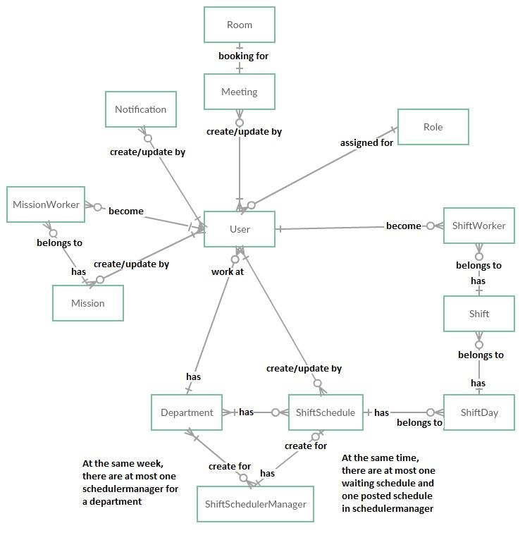

|  |  |
| --- | --- |
| **Entity Data dictionary: describe content of all entities** | |
| **Entity Name** | **Description** |
| **User** | *Contain the user information.* |
| **Mission** | *Contain the mission schedule information.* |
| **Room** | *Contain the room resources information.* |
| **Role** | *Contain the role information.* |
| **MissionWorker** | *Contain the mission worker for one mission.* |
| **Department** | *Contain the department information.* |
| **Meeting** | *Contain the meeting schedule information.* |
| **ShiftSchedule** | *Contain the shift schedule information.* |
| **ShiftScheduleManager** | *Contain the shift schedule manager information.* |
| **ShiftDay** | *Contain the shift day of week.* |
| **Shift** | *Contain the shift information.* |
| **ShiftWorker** | *Contain the shift worker for one shift.* |
| **Notification** | *Contain the notification information.* |

***Table 11: Conceptual Diagram Data Dictionary***